**Remarks on “Statistical Analysis” Challenges**

* Does the mean or the median better summarizes the data?

**Ans:** In this case, both the mean and median statistics do not summarize the data efficiently. Look at the variance, min, max and SD. data for both outcomes (successful and failed), this shows that the values are widely dispersed from their respective means. Also, the distributions of the data set are not normally distributed, and the box plot below shows lots of outliers. The median values of ***201*** and ***115*** for successful and failed outcomes respectively do not depict the distribution of the set, too.

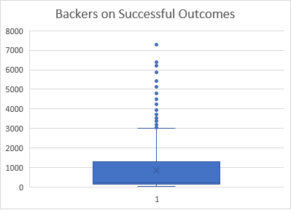

* Use your data to determine if there is more variability with successful or unsuccessful campaigns. Does this make sense? Why or why not?

**Ans:** Though both outcomes have high variances (and SD) values, the variability of ‘successful outcome’ is larger than the ‘failed outcome’. My remarks are based on higher variance and SD values for the successful outcomes relative to the failed outcomes. However, as remarked earlier, both values are huge, revealing that the values are widely dispersed from its center.